XN PROJECT: GROUP FINAL DRAFT

Sean McLean
Paula Andrea Romero Melo
Gauri Udaysing Shinde
Theodore R. Smith
College of Professional Studies, Northeastern University

Introduction
This report outlines a strategic plan to enhance digital sales and marketing for Yeoman Technology Group (YTG) using Amazon data. The analysis focuses on optimizing advertising strategies, boosting conversion rates, and improving brand positioning, emphasizing the need to target high search query areas and grasp market dynamics. Recommendations include advanced predictive modeling and the study of temporal trends to refine strategies. Regular stakeholder engagement and feedback are crucial for aligning outcomes with expectations. This highlights the importance of data-driven approaches in transitioning to digital platforms and achieving a competitive edge in the digital marketplace.
Executive Summary
A comprehensive strategic plan to increase digital sales and marketing initiatives for Yeoman Technology Group (YTG) has been outlined in this report through careful examination of Amazon data. The prime objective of the project is to uncover meaningful findings that can lead to optimized advertising strategies, improved conversion rates, and strengthened brand positioning. This project seeks to use sophisticated data analytics approaches to identify valuable search query locations and clarify market dynamics, thus giving YTG a competitive advantage in the digital marketplace.
The analysis conducted by each team member has highlighted key areas of focus; particularly Market Share Clicks and Search Queries. These insights are used as a basis for tailored strategic recommendations aimed at YTG. Proposed strategies include using advanced predictive modeling to forecast market trends and consumer behavior and examining temporal trends for fine-tuning advertising and merchandising efforts.
Also, the report underscores the significance of regular stakeholder engagement and feedback loops for ensuring that strategies are aligned with client’s expectations and business goals. By embracing data-driven decision-making, YTG will have an easy transition into digital platforms while improving its market presence.
Business Problem
Faced by the modernization of its sales and marketing approaches to survive in this era of technology, Yeoman Technology Group (YTG) is grappling with how to win over customers who have already built-up pre-Internet brands. This entails strengthening digital sales channels without disrupting existing wholesale and retail functions.
To achieve this, YTG must examine Amazon data for deeper understanding of client insights into pricing dynamics, advertising effectiveness, and merchandising strategies. The main objective is to create scalable models for Brand Influence and Ad Spend Optimization that can be consistently applied across different client scenarios. These models will help refine advertising strategies, optimize ad spend and improve brand position on Amazon so that YTG clients can compete effectively within an increasingly digital marketplace.
Key strategic objectives consist of:
Understanding Market Share Clicks: Analyzing click data for which products and brands are gaining traction and identifying opportunities for increasing market share.
Optimizing Search Query Performance: Identifying high-value search queries and adjusting advertising strategies to capture them thereby enhancing visibility while conversion rates are simultaneously improved.
Developing Predictive Models: Using predictive analytics to predict market trends and consumer behavior.
Project Scope
To maintain a professional project's workload, defining the project's goal and objectives is crucial to focus efforts and avoid unnecessary work. The team's needs for this project are to find business answers and insights from the provided datasets. The results need to be packaged concisely and clearly. The scope involves exploratory data analysis (EDA), focusing on five popular brands and the five smallest brands to determine correlations between spending and profit.
Acceptance comes strictly from sponsor feedback, and the goal is to provide general insights and then finalize the results based on feedback. Primary constraints include limited access to the sponsor and the dataset provided by YTG which helps focus the analysis. The primary stakeholders are YTG, the course instructor, and the project team. Regular updates and feedback sessions are crucial. Ethical considerations include ensuring ethical handling of data, maintaining confidentiality, and integrity in the analysis.
Analytical Approach
The analytical approach includes exploratory data analysis (EDA) and various business intelligence (BI) and machine learning techniques. The EDA methods involve descriptive statistics, data visualization, correlation analysis, conversion funnel analysis, and segmented analysis. The BI analysis includes trend analysis, performance metrics calculation, comparative analysis, and creating visualizations like dashboards and heatmaps. Machine learning analysis encompasses predictive analytics, clustering, classification, regression analysis, and natural language processing (NLP). Specific models developed include a Brand Influence Model to quantify brand impact on search queries and an Advertising Effectiveness Model to optimize advertising spending and to calculate ROAS.
Analytics / Visuals
Key insights from the analysis include the dominance of a few brands, high barriers to entry, and significant competition intensity, indicating a mature market. The relationship between search query volume and ad impressions suggests focusing advertising on high search query areas to increase ad visibility. Brand frequency analysis shows the strong presence of top brands, with niche or newer entrants having lower frequencies. Market share analysis reveals a wide range of shares among brands, highlighting the potential for smaller brands to increase sales and profit.
The clicks versus purchases analysis indicates low engagement and conversion for most queries, with recommendations to optimize high-click, low-purchase queries. Simplified distribution of clicks by brand shows dominance of top brands like Dash & Albert and Kaspene Home. Association mining techniques reveal key metrics such as support, confidence, and lift, useful for identifying common combinations, targeted marketing, and enhancing recommendation systems.
Recommendations & Findings
Key Insights from Brand Share Histogram
Market Dominance: A few brands dominate with most percentages clustered between 75-100%, indicating significant market concentration and could mean significant barriers to Entry. High prevalence of zero percent suggests barriers to entry such as strong brand loyalty and high entry costs.
Competition Intensity: The wide gap between zero percent and dominant brands indicates a highly competitive market environment.
Market Maturity: Concentration at extremes suggests a mature market, posing challenges for new entrants but opportunities for differentiation through strategic innovation and marketing.
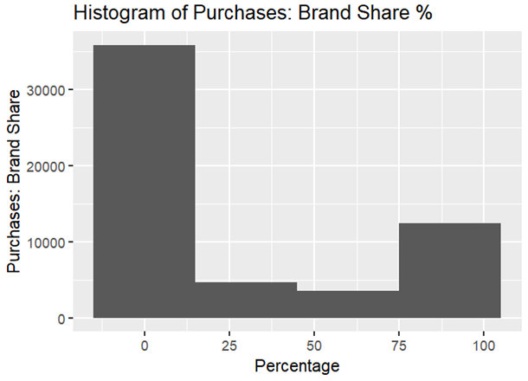

Search Query Volume vs. Impressions
Observation: A linear relationship is prevalent between search query volume and ad impressions. Implication: Focusing advertising efforts in areas with high search query volumes may be more effective in reaching a broader audience and increasing ad visibility.
Brands Frequency
Brand Popularity: There is a strong market presence in the top five brands, with niche players probably being a factor. The lower frequency occurrences may indicate there are niche players or newer entrants. Each factor makes them prime candidates for greater marketing and increasing brand awareness.
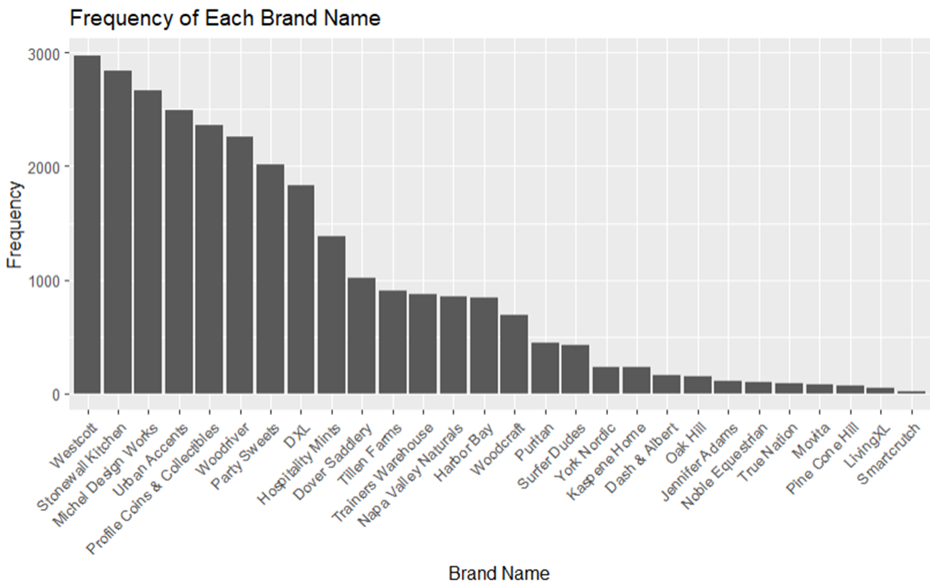
Market Share by Company
Observation: There is a wide range of market shares for each company/brand, creating an opportunity where smaller market shares have the potential for greater percentage increases in sales and profit. This leads to the question of whether smaller brands are willing to invest in the effort and capital for this transformation.

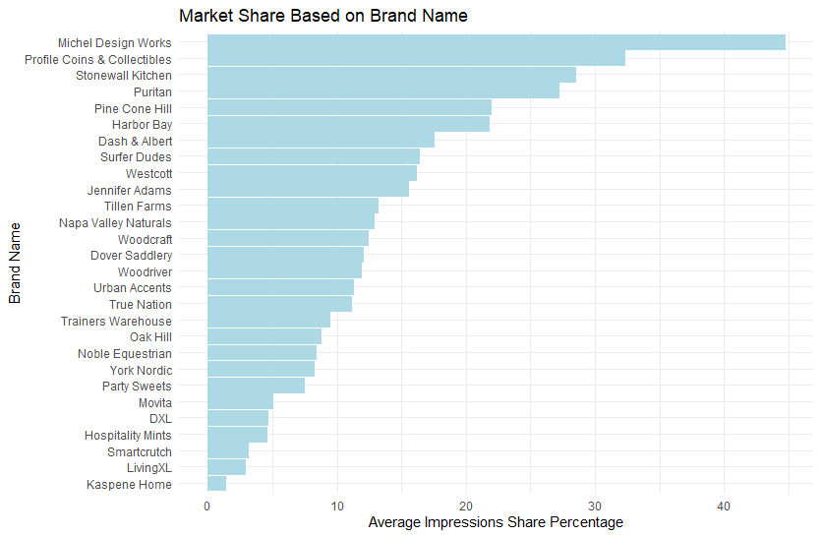

Clicks vs. Purchases
In the graphic below there is a great deal of data concentration with most queries having low clicks and purchases, indicating low engagement and conversion. There are several outliers where some queries have high clicks but low purchases, highlighting inefficiencies in conversion. One important recommendation is to focus on optimizing high-click, low-purchase queries to improve overall performance.
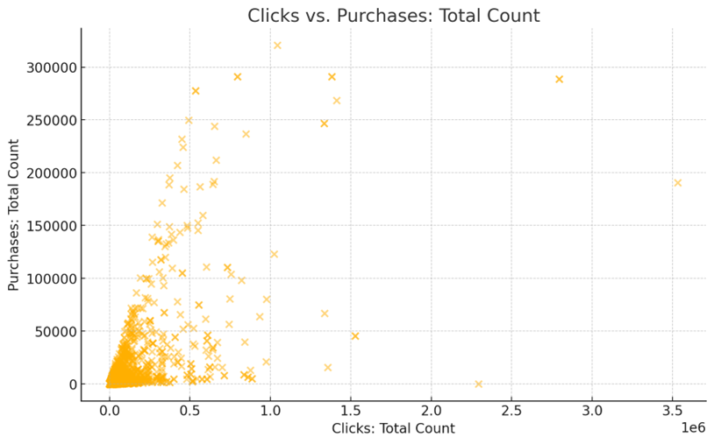
Simplified Distribution of Clicks by Brand
Dash & Albert: The largest share of total clicks, indicating high user interest and engagement.
Kaspene Home: Substantial portion of clicks, reflecting strong brand visibility.
Urban Accents: Significant share, suggesting effective query performance.
PineCone Hill: Moderate clicks, indicating steady user interest.
Stonewall Kitchen: Noticeable portion of clicks, showing competitive engagement.
Others: Aggregated smaller brands, highlighting the dominance of top brands.

Association Mining of Dataset
Understanding key metrics involves support which measures the frequency of item sets in the dataset, and confidence which indicates the reliability of the rule and how often items appear together. Lift is the other metric which reflects the strength of association, with higher values indicating stronger associations.
Interpreting the scatter plot involves recognizing that high support and confidence indicate reliable but less frequent item sets that are valuable for strong associations, while high lift suggests strong associations with potential cross-selling opportunities. Additionally, a dense low support cluster contains many item sets with low frequency but potentially high confidence and lift, revealing interesting associations.
The implications for Amazon include identifying popular item sets for inventory and promotions and leveraging reliable associations with high confidence rules for targeted marketing. Uncovering hidden relationships through high lift insights can enhance recommendation systems and boost sales through strategic product placements.
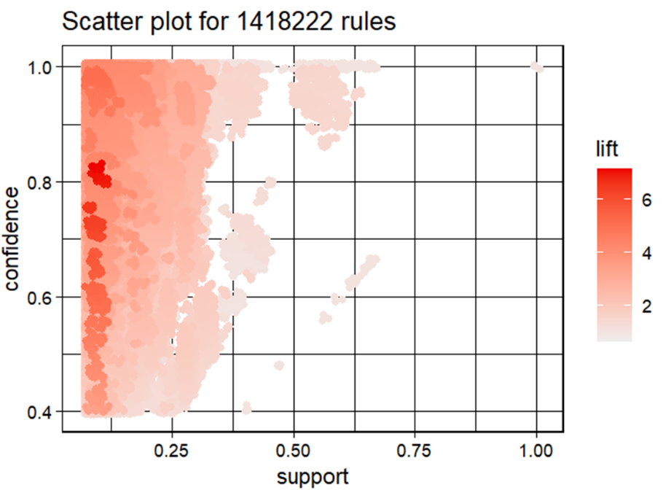
Recommendations include optimizing advertising strategies by focusing on high search query areas, enhancing brand positioning using insights from brand share and search query analysis, and improving conversion rates by addressing high-click, low-purchase queries. These recommendations aim to enhance digital sales and marketing strategies for YTG.
Future Research
Future research should focus on continued refinement of the analysis to provide specific guidance for YTG. Advanced predictive modeling can forecast future sales trends and customer preferences, aiding in more accurate business decisions.
Our primary recommendation is to use machine learning to determine which factor results in the most profit. Is spending money on marketing in-house for clicks on Amazon the smart way to go or should the companies spend money on brand awareness to get more results from primary searches? To accomplish this logistic regression type of analysis, YTG would need to directly compare situations where they have spent money on marketing and when they have not. The dataset the group received is strictly an organic dataset, and this makes it convenient for comparison. If there is a dataset that has past information about where companies have spent money on marketing, the analytics team could create an additional column for this data with binary inputs.
Milestones
Key milestones include analyzing the pros and cons of the XN Project, deeper exploration of the project, creating an interview guide, and developing a project roadmap. After presenting mid-term progress, the team created a project scope document, submitted a project draft and final draft, prepared a presentation slide deck, and gave the final project presentation. Each milestone has specific dates and includes a summary of the activities completed and submitted.
Key Risks and Strategies
Key risks include data security and privacy, consistency and quality of data, and integration with current systems. Strategies to mitigate these risks include using strong encryption protocols and strict access controls, implementing strong data validation and cleaning procedures, and creating precise integration plans and schedules. Training and support for the company team will also facilitate successful implementation of new models.
Stakeholder Engagement and Feedback Integration
Regular engagement with stakeholders is crucial for alignment and refining analysis. Feedback sessions will help ensure the final deliverables meet the desired standards of quality and relevance. This iterative process fosters open communication channels and receptiveness to constructive criticism, enhancing the value of recommendations and increasing the likelihood of successful implementation by YTG.
Keys to Successful Project Management
Successful project management involves agreement on acceptable quality levels, efficient resource management, regular feedback sessions, and clear documentation. Ensuring high quality within the limited time frame requires balancing the pursuit of quality, resource allocation, and adherence to the project schedule. Regular updates and meetings help track progress and address any issues promptly. Maintaining thorough documentation ensures transparency and ease of review.
Conclusion
This report presents a strategic plan to boost digital sales and marketing for the Yeoman Technology Group (YTG) through the utilization of Amazon data. The analysis centers on refining advertising strategies, increasing conversion rates, and strengthening brand positioning. Key findings emphasize the significance of focusing on high search query areas and comprehending market dynamics. Recommendations include employing advanced predictive modeling and examining temporal trends to enhance strategies. Regular engagement with stakeholders and incorporating their feedback are essential for meeting expectations. This project highlights the importance of data-driven strategies in transitioning to digital platforms, enhancing business performance, and gaining a competitive edge in the digital market.

References
Chaffey, D. (2020). Digital marketing strategy: Implementation and practice. Pearson.
Champigny, A. (2024, May 18). 6 Ways to Measure Your Consulting Firm’s Performance. Deltek.
Fathalla, A., Salah, A., & Ali, A. (2023). A Novel Price Prediction Service for E-Commerce Categorical Data. Mathematics (Basel), 11(8), 1938- . https://doi.org/10.3390/math11081938
Guiding Metrics. (2024, May 18). The Management Consulting Industry’s 10 Most Critical Metrics.
Shopova, R. (2023). Private labels in marketplaces. International Journal of Industrial Organization, 89, 102949-. https://doi.org/10.1016/j.ijindorg.2023.102949
Stokes, R. (2014). eMarketing: The essential guide to marketing in a digital world. Quirk eMarketing.
Zhang, J., & Nault, B. R. (2024). Upstream information sharing in platform-based e-commerce with retail plan adjustment. DECISION SUPPORT SYSTEMS, 177, 114099-114111. https://doi.org/10.1016/j.dss.2023.114099

